LAPORAN PRAKTIKUM PENGOLAHAN CITRA DIGITAL
7. HISTOGRAM EQUALIZATION AND SPECIFICATION



Disusun oleh :
Nama :
NPM :
Kelas : IF4..

PROGRAM STUDI INFORMATIKA
FAKULTAS ILMU KOMPUTER DAN REKAYASA
UNIVERSITAS MULTI DATA PALEMBANG
2024
TUTORIAL : HISTOGRAM EQUALIZATION AND SPECIFICATION

Goal
The goal of this tutorial is to learn how to use the IPT for (global and local) histogram
equalization and histogram specification (matching).

Objectives
- Explore the process of histogram equalization.
- Learn how to use the histeq function.
- Learn how to perform histogram specification (matching).
- Explore the Interactive Histogram Matching demo.
- Learn how to perform local histogram equalization with the adapthisteq function.

What You Will Need
ihmdemo.m—interactive Histogram Matching demo M-file

Procedure
Let us begin by using the function histeq to perform histogram equalization on our
own images, and by using the imhist function, we can view the histogram of the original and the adjusted image.
- Display the image pout and its histogram.
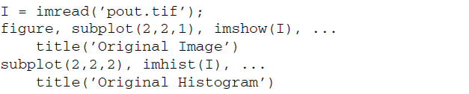
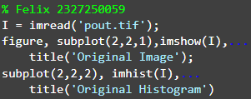
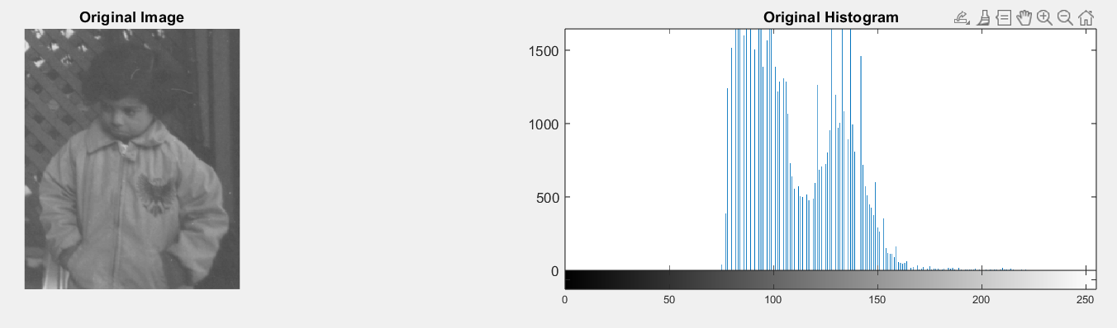

- Use the histeq function to perform histogram equalization.
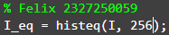

Question 1 Why must we include the second parameter (256) in the histeq
function call?
Parameter kedua dalam fungsi histeq(I, 256) digunakan untuk menentukan jumlah keabuan, yang Dimana 0-255, parameter ini membantu memperjelas atau memperbagus kontras gambar. Akan tetapi hal tersebut tidak bisa di lihat dengan mata secara lengsung, kita bisa membandingkan nya dengan menggunakan imhist().
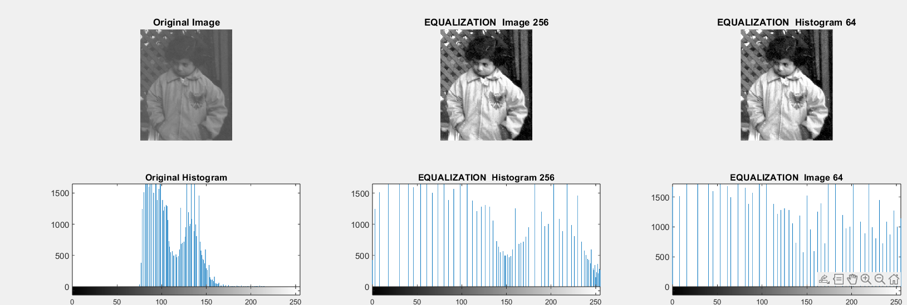

- Display the equalized image and its histogram.
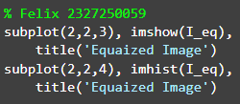
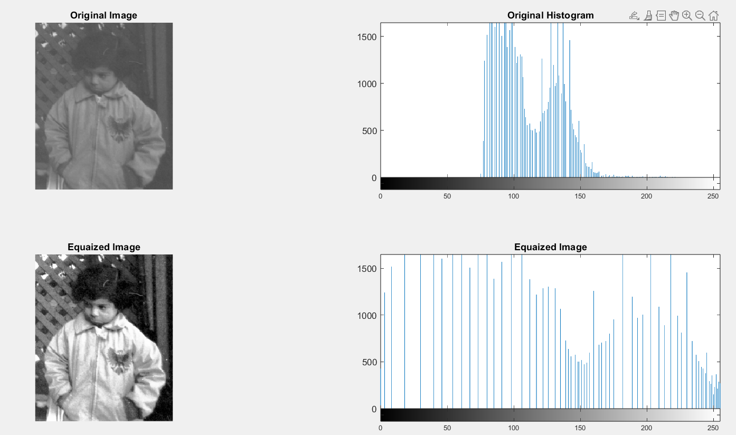

Question 2 What is the effect of histogram equalization on images with low contrast?
Efek pemerataan histogram (histogram equalization) pada gambar dengan kontras rendah adalah meningkatkan kontras dengan menyebarkan nilai intensitas piksel secara lebih merata ke seluruh rentang intensitas (0–255). Hal ini membuat detail pada area gelap atau terang yang sebelumnya sulit terlihat menjadi lebih jelas.
Namun jika dilakukan dengan salah yang terjadi akan kehilangan warna aslinya.

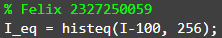
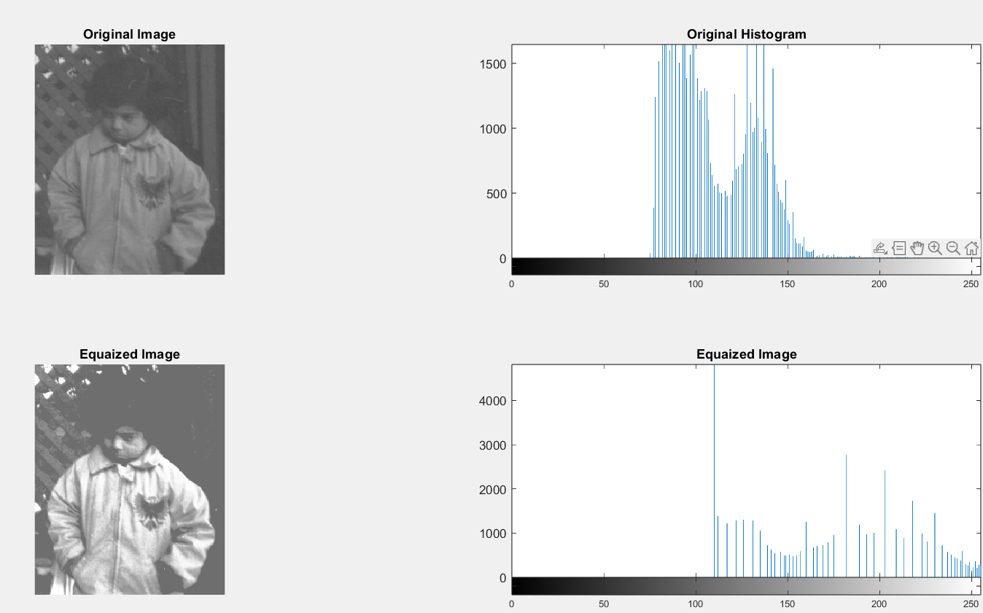

- Close any open figures and clear all workspace variables.
- Execute the following code to perform histogram equalization on the tire image.
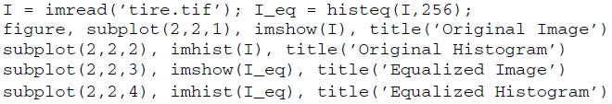
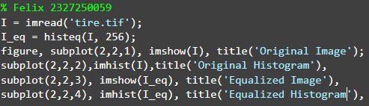
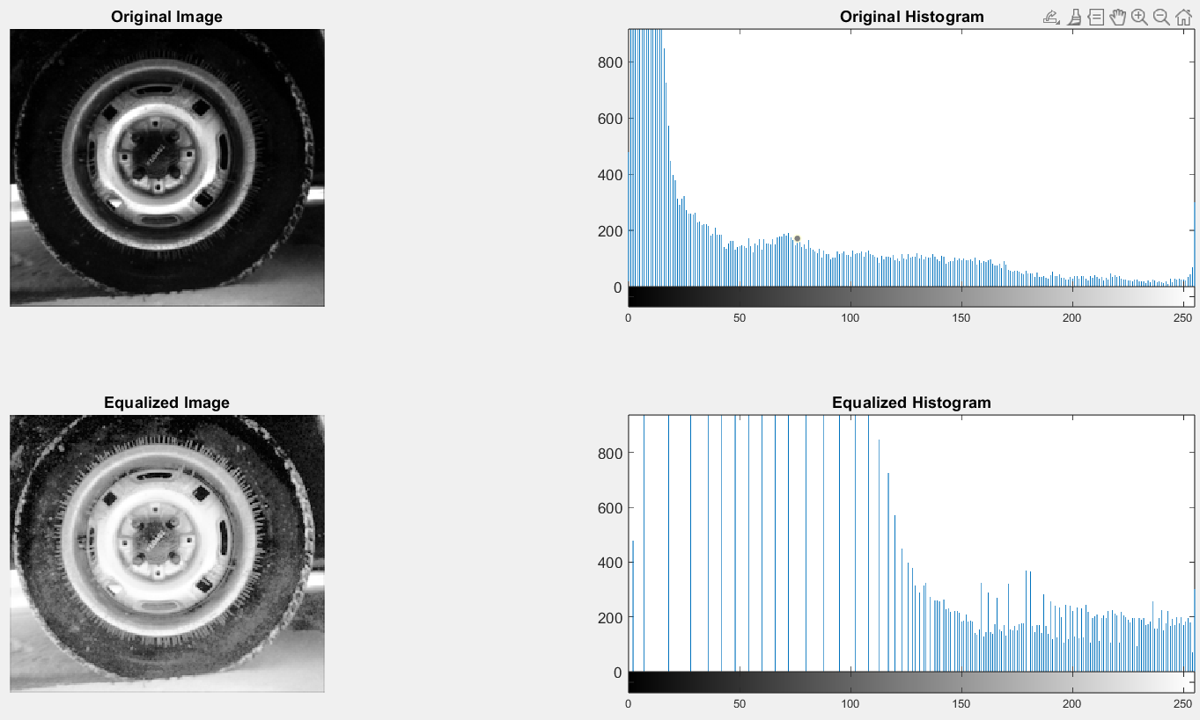

Question 3 Based on the tire image’s original histogram, what can be said about its overall brightness?
Yang damap dilihat bahwa warna putih lebih diminan karena pada gambar awal sudah memiliki banyak warna putih, karena otomatis oleh histeq() untuk meratakan warnanya jadilahhasilnya pada gambar menjadi seperti lebih terang.

Question 4 How did histogram equalization affect the overall image brightness in this case?
Pemerataan histogram mempengaruhi gambar keseluruhan dengan menyebarkan intensitas piksel secara merata keseluruhnya. Dalam kasus ini, gambar memiliki intensitas warna putih secara dominan, maka fungsi histeq() akan menyesuaikan distribusi tersebut sehingga area terang tidak terlalu mendominasi, dan detail di area lain menjadi lebih terlihat.

Histogram equalization does not always perform well. As we will see in the next steps, it depends on the original image.

- Close any open figures and clear all workspace variables.
- Perform histogram equalization on the eight image.
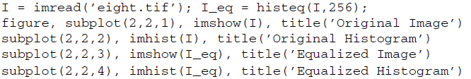
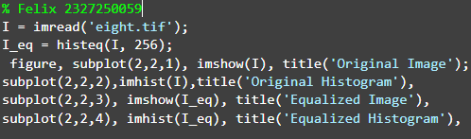
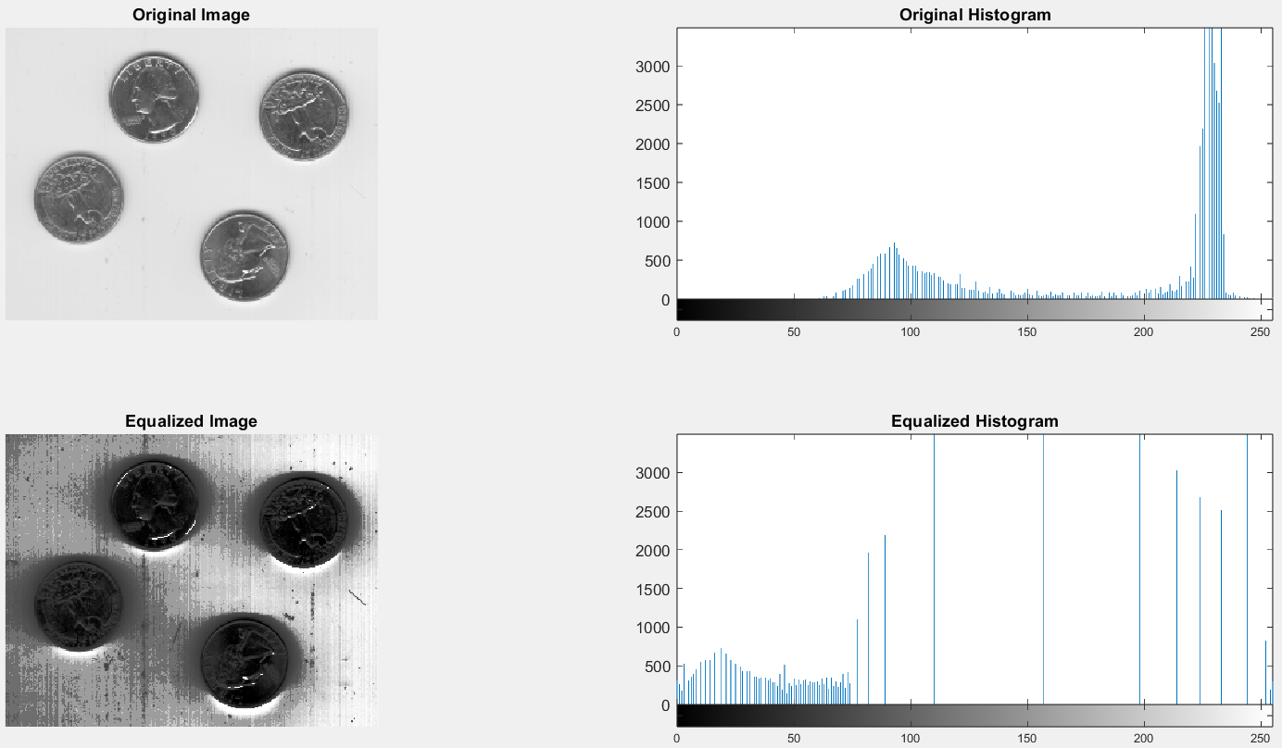

Question 5 Why was there such a loss in image quality after histogram equalization?
Karena seperti yang kita ketahui bahwa Pemerataan histogram mempengaruhi gambar keseluruhan dengan menyebarkan intensitas piksel secara merata keseluruhnya. Dalam kasus ini gambar memiliki wanra itensitas yang sedikit rumit yang dimana pada satu bagian abu-abu dan pada bagian lain memiliki intenstas warna yang lebih gelap, maka gambar yang di hasilkan kacau diakibatkan equalization mengutamakan persebaran intensitas, bukan menjaga tampilan asli.

The transformation function for histogram equalization is simply the cdf of the original image.

- Display the normalized cdf for the eight.tif image.
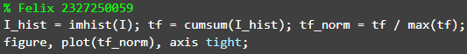
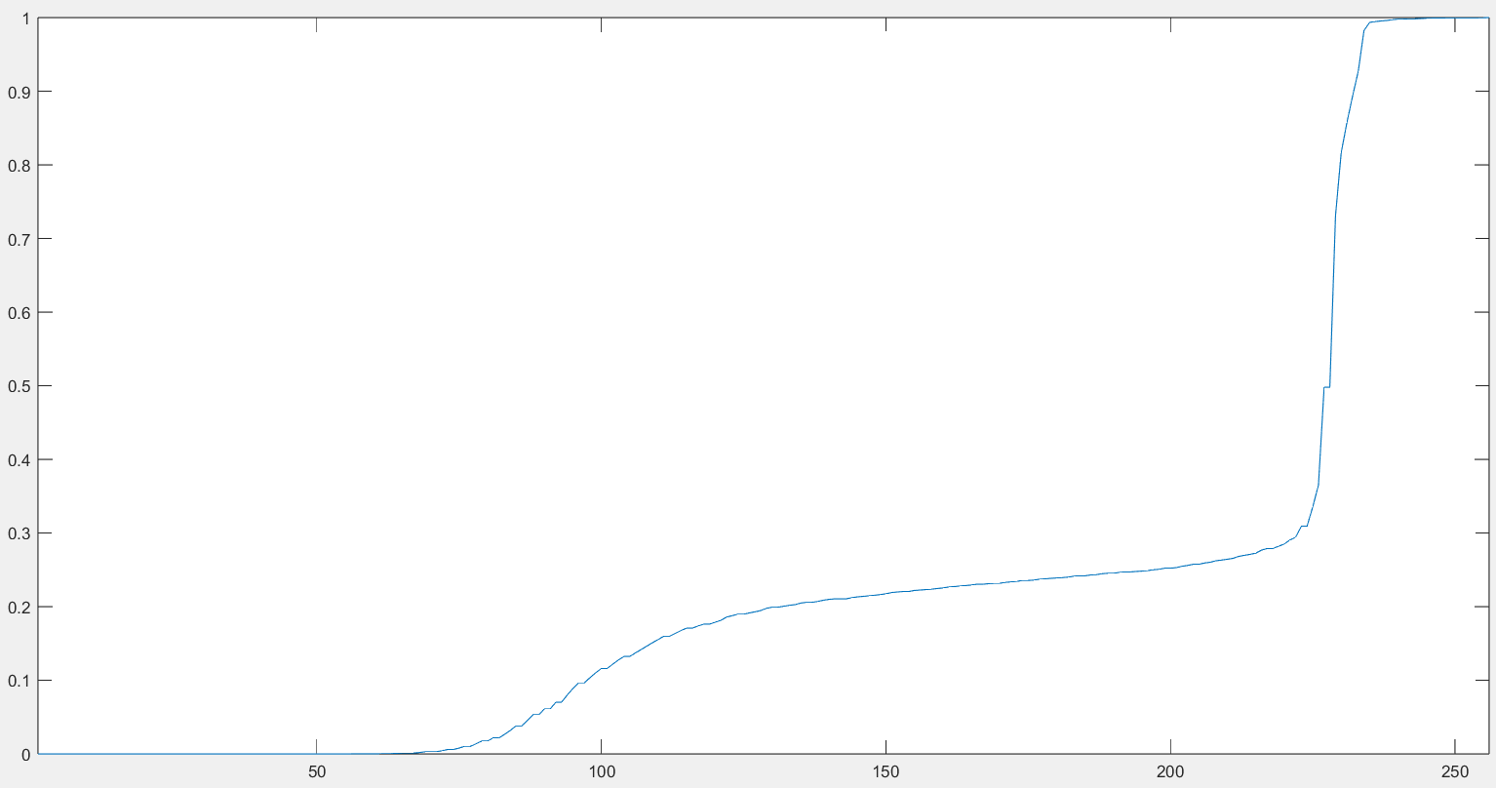

Question 6 What does the cumsum function do in the previous step?
Menghitung jumlah kumilatif dari sebuh array.

- The transformation function can also be obtained without using the cumsum function.
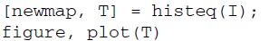
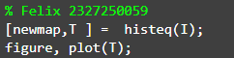
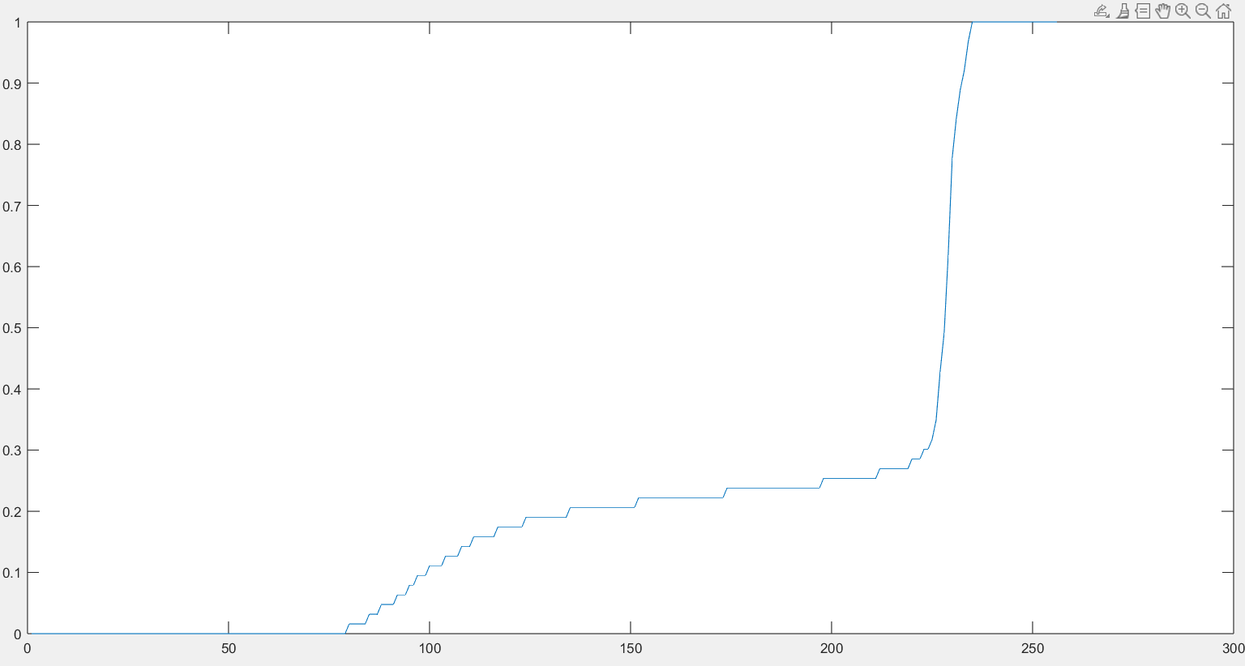

As we have learned, the histogram equalization process attempts to flatten the image histogram. Histogram specification (also known as histogram matching) tries to match the image histogram to a specified histogram. The histeq function can also be used for this operation.

- Close any open figures and clear all workspace variables.
- Prepare a subplot and display original image and its histogram.
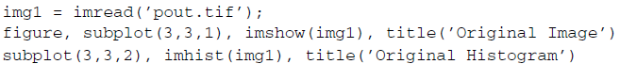
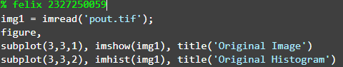
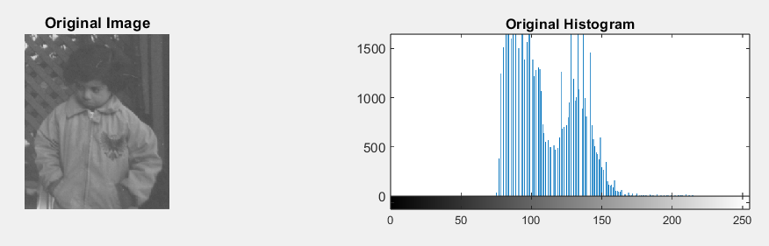

- Display the image after histogram equalization for comparison.
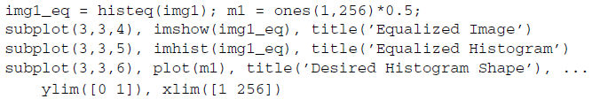
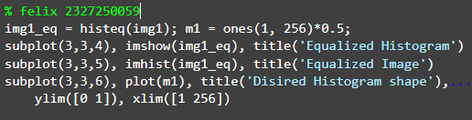
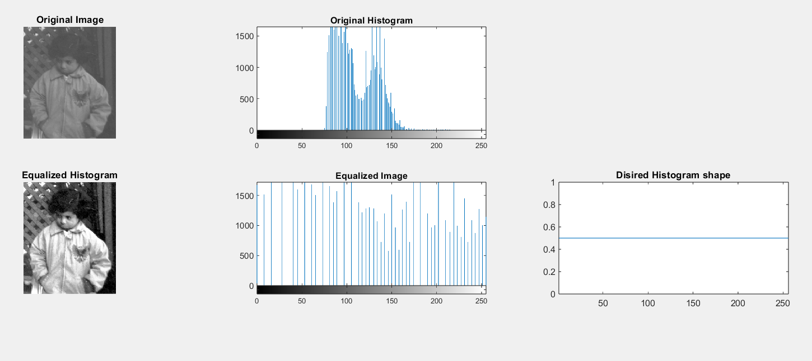

- Display matched image where the desired histogram shape is a straight line from (0, 0) to (1, 1).
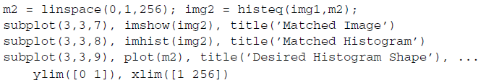
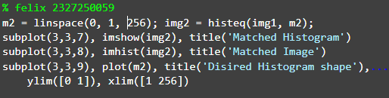
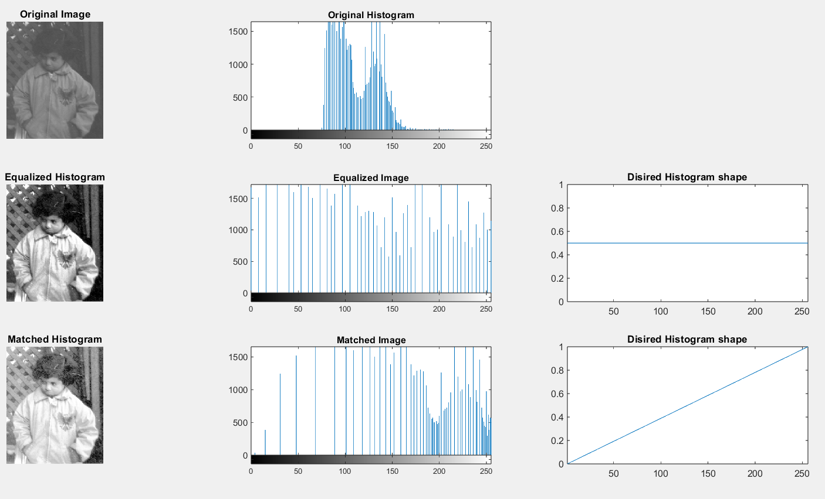

As we can see from the previous steps, performing histogram specification means we must generate a function that represents the shape of the desired histogram. The Interactive Histogram Matching demo (developed by Jeremy Jacob and available at the book’s companion web site) shows us how creating a desired histogram shape can be an interactive process.

- Close any open figures and clear all workspace variables.
- Run the Interactive Histogram Matching demo.
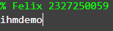

- Experiment with creating your own desired histogram shape. To create new points on the function curve, click the curve at the desired location. To move a point, press and drag the point. To delete a point, simply click it.

Question 7 What does the Continuous Update checkbox do?
saat dicentang, setiap perubahan pada kurva histogram akan langsung diterapkan ke gambar secara otomatis.

Question 8 How do the different interpolation methods change the shape of the desired histogram curve?
Menggunakan Metode interpolasi yang berbeda, yang dimana berfungsi untuk kasar, gatis lutus, halus.

Question 9 How can the demo be loaded with a different image?
lik tombol Load Image, lalu pilih file gambar dari komputer.

Local histogram equalization is performed by the adapthisteq function. This
function performs contrast limited adaptive histogram equalization (CLAHE) and operates on small data regions (called tiles), whose size can be passed as a parameter.

- Perform local histogram equalization on the coins image.
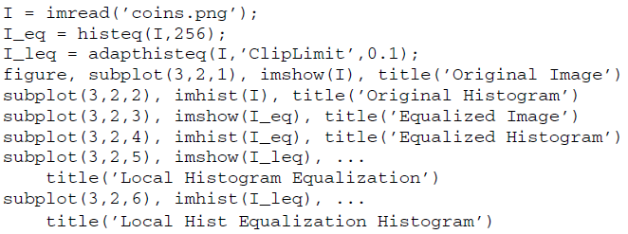
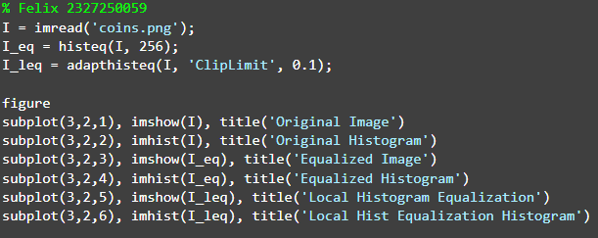
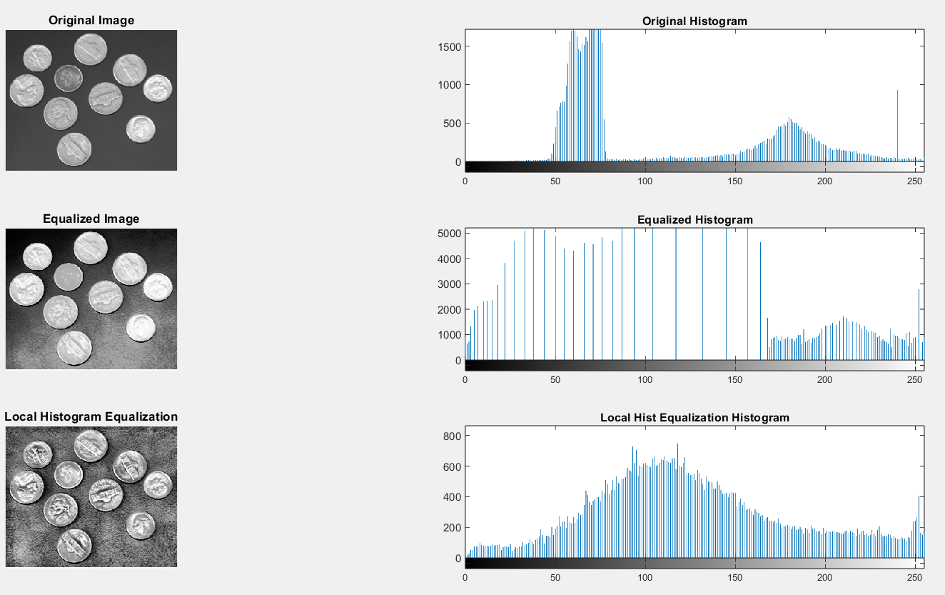

The original image’s histogram is clearly bimodal, which separates the pixels of the background from the pixels that make up the coins. We have already seen how images with bimodal distribution of pixel shades do not perform well under (global) histogram equalization.

Question 10 What does the ClipLimit setting do in the adapthisteq function?
berfungsi untuk mengontrol seberapa banyak kontras yang ditingkatkan selama proses local histogram equalization

Question 11 What is the default tile size when using adapthisteq?
Ukuran default adapthisteq 256 bins

